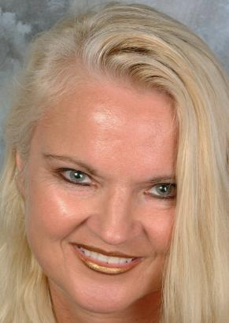
Realize that you are not alone & we are in this journey together!

* Escape from the Ordinary
Album: “Holy Holy”
* Success Through the Power of the WORD of God * Gain a new perspective
Dr. Dietz wrote and sang in the new Gospel, Christian album called “Holy Holy”:

Enjoy the sounds of reggae, jazz, soul, rock, blues blended into country Gospel, Christian sounds with lyrics taken directly from the Bible. Fourteen songs inspired by the Holy Spirit entitled:
- Holy Holy
- Jesus is the One
- Love is in the Air
- Heaven (and more)….

* Freedom from Condemnation
*Changing Behavior
* Renewal of Your Mind
Have Janell Emcee or Speak
Customized inspirational topics serve to reinforce your meeting objectives, while keeping the event focused. Janell can also sing and play music during the event.
Who is Dr. D. Janell Dietz? MFT, Ed.D, M. Ed. NCC
She is a Marriage & Family therapist, singer, songwriter, author, teacher and board certified counselor. She has worked for the USO troops in South Korea, USA, Canada, and performed on radio, television, & with the Beastie Boys. She headlined at the Riverside. www.drjanelldietz.com

